**FOR 4-5 YEARS OLD CHILDREN**

**Arts and Creativity Activities**

1. **Finger Painting Fun**  
   **Description:** Let the child dip their fingers into paint and create patterns on paper.  
   **Materials:** Paper, washable paints.  
   **Duration:** 30 minutes.

<https://youtu.be/8Mq2eqUu7-s?si=apbYhAXBRU0Q8ngq>

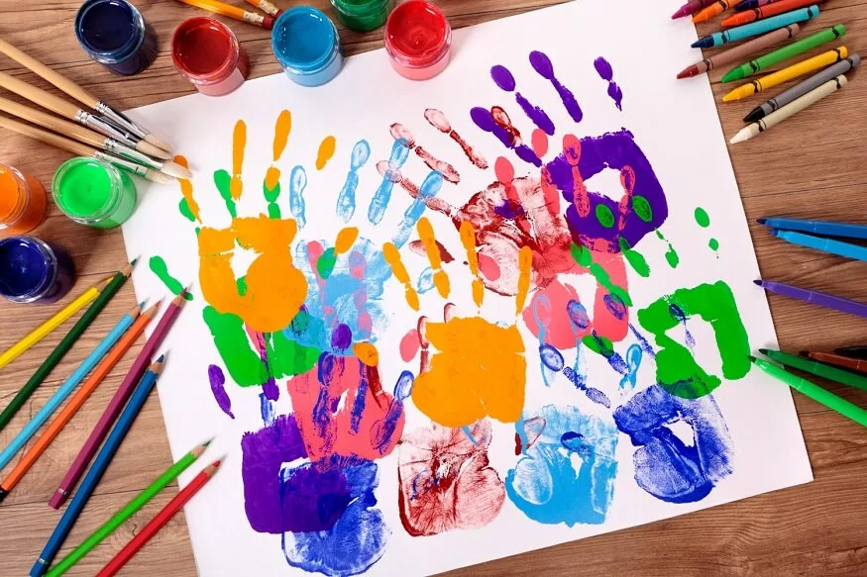

1. **Cardboard Box Creations**

**Description:** Transform a cardboard box into a car, spaceship, or house. Decorate with markers or crayons.  
**Materials:** Cardboard box, markers, tape, scissors.  
**Duration:** 45 minutes.

<https://youtube.com/shorts/ZMc-AL8k690?si=sq-Vl0c98eDF49cJ>

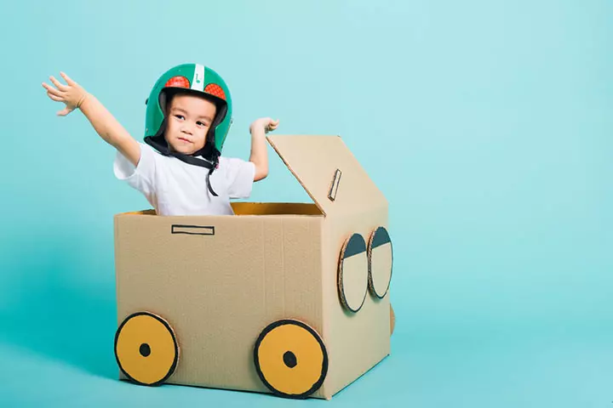

1. **Homemade Playdough Sculpting**

**Description:** Make playdough at home and sculpt animals, letters, or shapes.  
**Materials:** Flour, salt, water, food coloring (optional).  
**Duration:** 30-45 minutes.

<https://youtu.be/PehxxBY-U-I?si=MERhb8PTgU_vf_jN>  
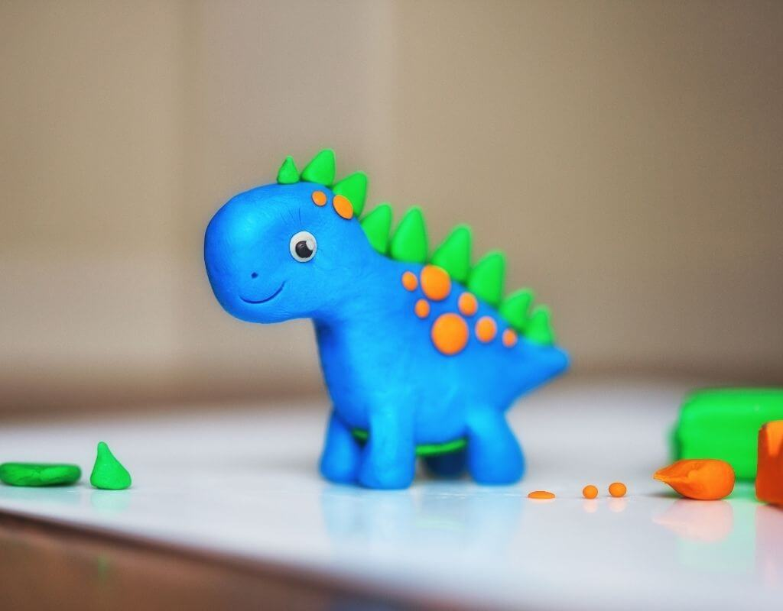

1. **Paper Plate Masks**  
   **Description:** Create masks using paper plates and decorate them with colors and cutouts.  
   **Materials:** Paper plates, markers, scissors, glue, yarn.  
   **Duration:** 30 minutes.

<https://youtu.be/jBsfcQwJDsQ?si=CZQHcDbE7fkggkH6>

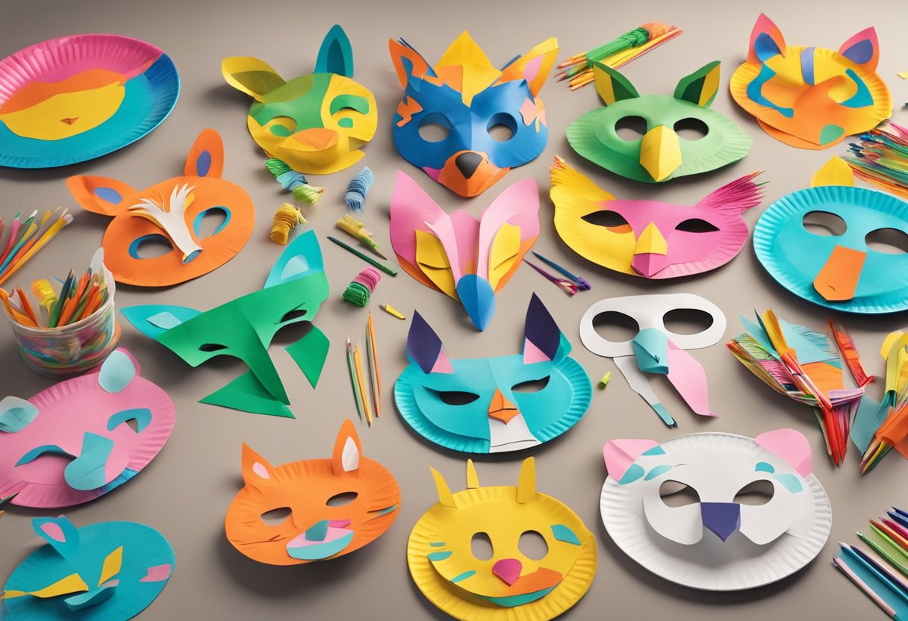

1. **Leaf Painting**

**Description:** Paint leaves and press them onto paper to create patterns.  
**Materials:** Leaves, paints, paper.  
**Duration:** 20-30 minutes.

<https://youtube.com/shorts/RvZSxNgbw4I?si=jZ99eDVZw4OMi7Zq>

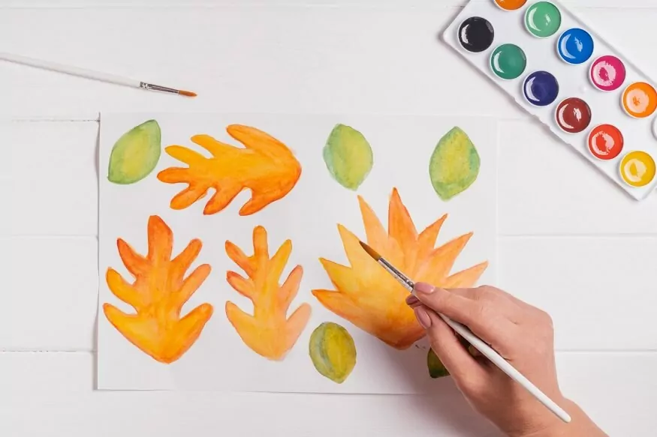

1. **Pasta Necklaces**

**Description:** Dye pasta and string them to make necklaces or bracelets.  
**Materials:** Uncooked pasta, food coloring, string.  
**Duration:** 30 minutes.

<https://youtube.com/shorts/SKuUnHKmxl0?si=lGkPDPEBjcucsUtH>  
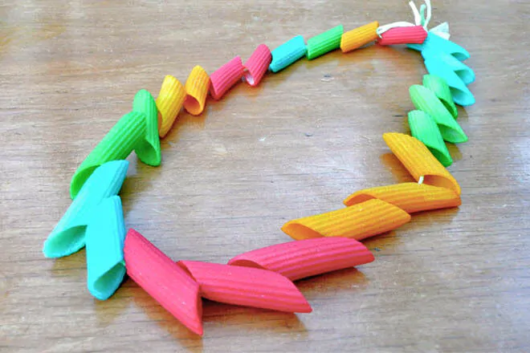

1. **Cupcake Liner Flowers**

**Description:** Make flowers using cupcake liners and decorate them.  
**Materials:** Cupcake liners, glue, paper, markers.  
**Duration:** 20-30 minutes.

<https://youtube.com/shorts/gsB4A5VfH14?si=xIFlSGwcnwq_MLvg>  
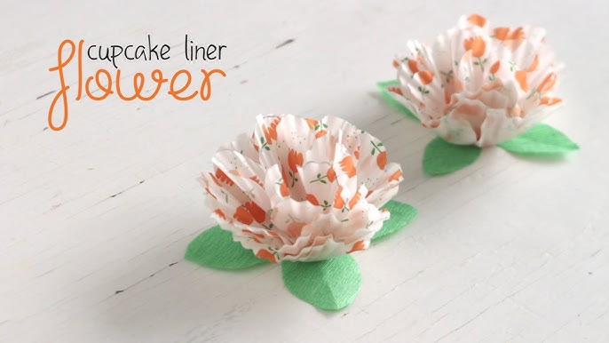

1. **DIY Stamps**

**Description:** Cut potatoes or sponges into shapes and use them as stamps.  
**Materials:** Potatoes/sponges, paint, paper.  
**Duration:** 30 minutes.

<https://youtube.com/shorts/pdAGxfI16ec?si=1sE2oMSes_IaYRTO>  
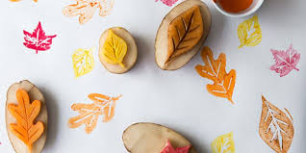

1. **Magazine Collage Art**  
   **Description:** Create collages by cutting and pasting magazine pictures.  
   **Materials:** Old magazines, glue, paper, scissors.  
   **Duration:** 30 minutes.

<https://www.youtube.com/shorts/B4vZXJr2MIg>

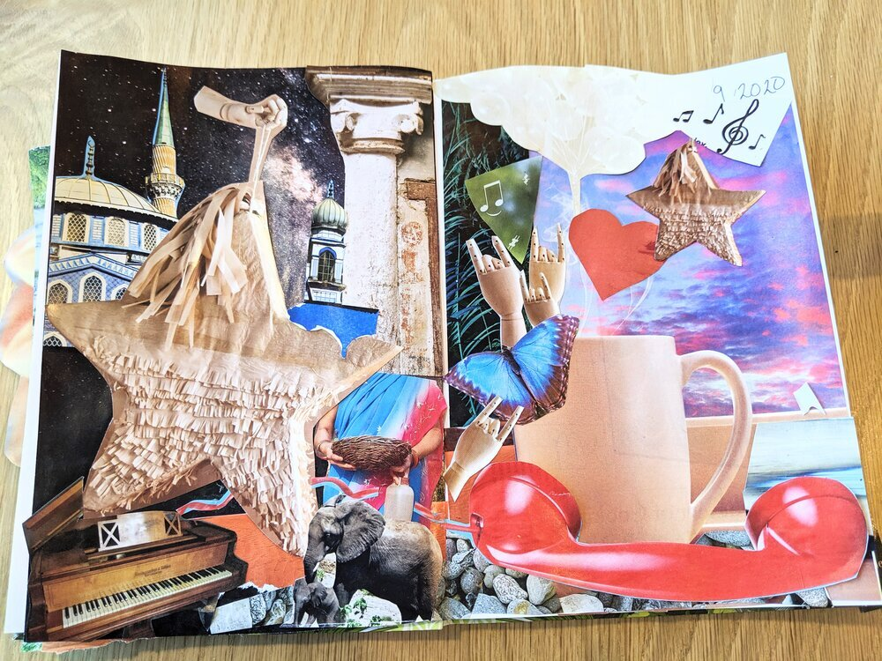

1. **Shadow Tracing**  
   **Description:** Trace the shadows of toys or objects onto paper.  
   **Materials:** Toys, paper, pencil, flashlight.  
   **Duration:** 20 minutes.

<https://www.youtube.com/watch?v=FyyJDXq-7uU>

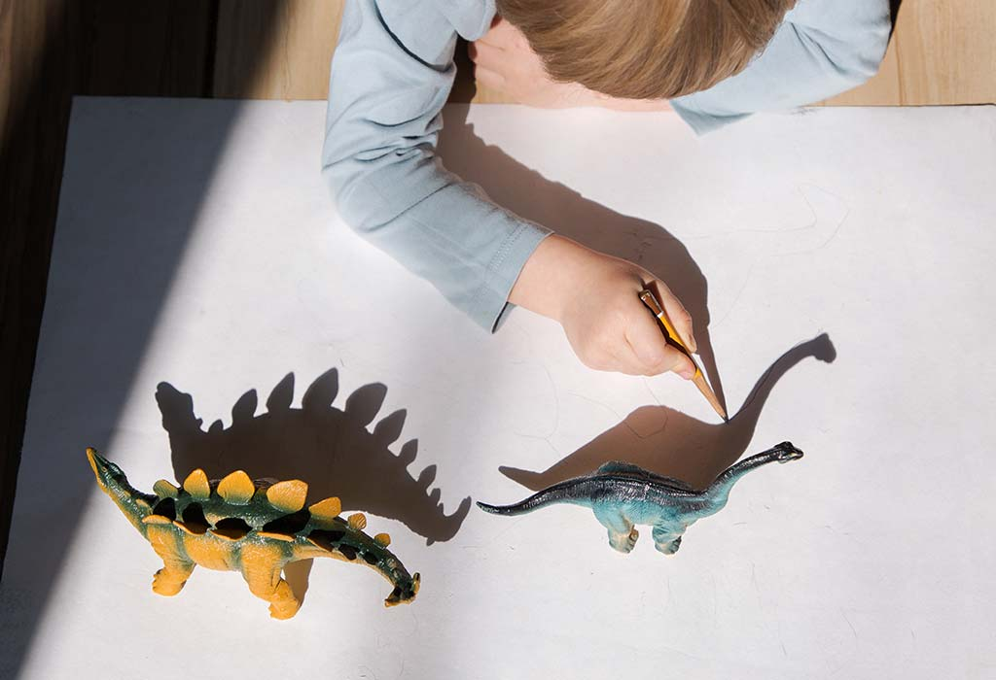

1. **Build a Tower Challenge**

**Description:** Build towers with blocks or cups and decorate them.  
**Materials:** Blocks, cups, markers.  
**Duration:** 30 minutes.

<https://www.youtube.com/shorts/QLjyuWut5rs>  
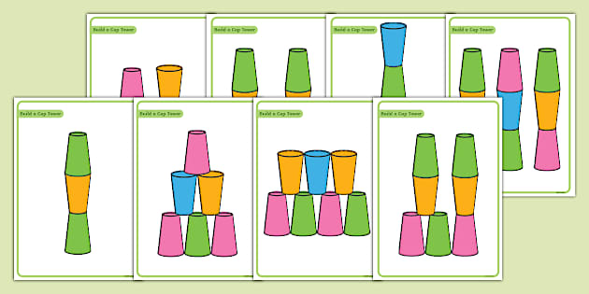

1. **Paper Airplane Decorating**  
   **Description:** Make paper airplanes and decorate them with designs.  
   **Materials:** Paper, markers.  
   **Duration:** 20-30 minutes.

<https://www.youtube.com/shorts/4Jlq1vEnIqM>

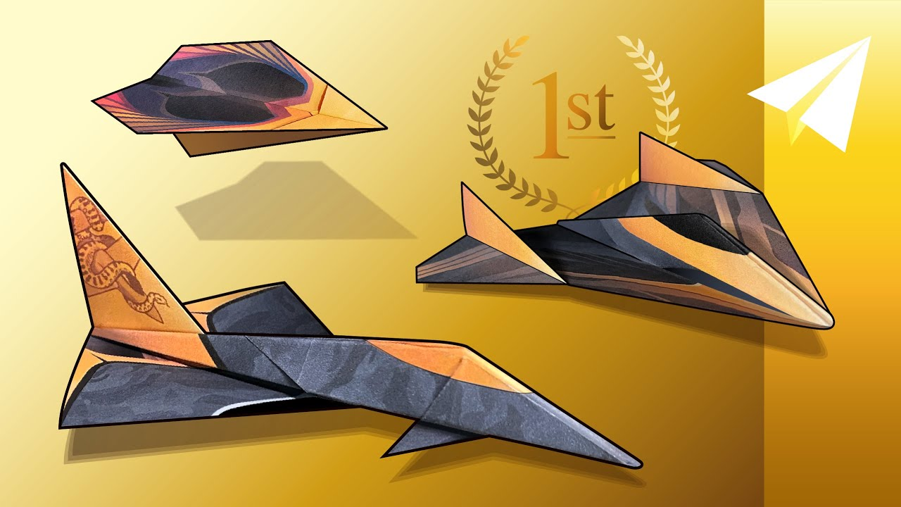

1. **String Art Fun**  
   **Description:** Use strings to create patterns or shapes on a cardboard base.  
   **Materials:** Cardboard, yarn/string, colors.  
   **Duration:** 30 minutes.

<https://www.youtube.com/watch?v=vuD3Xo1vK_Q>

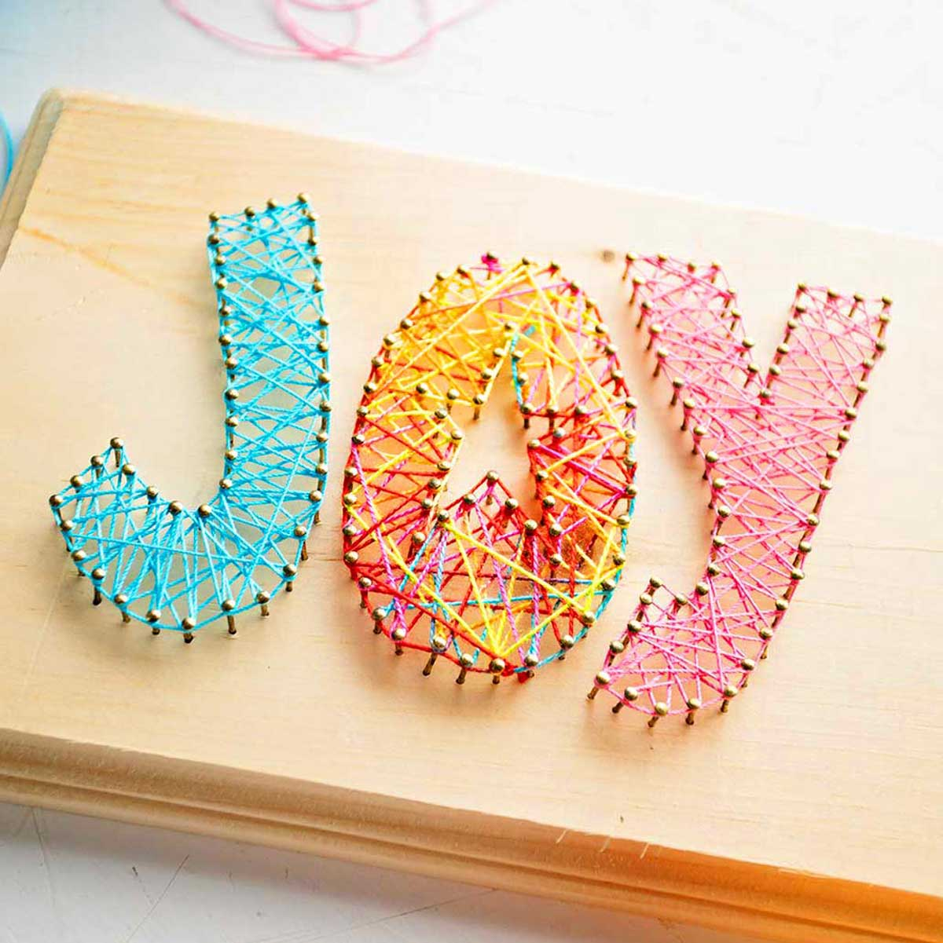

1. **Salt Dough Ornaments**

**Description:** Make ornaments with salt dough and paint them.  
**Materials:** Salt, flour, water, paints.  
**Duration:** 45 minutes.

<https://www.youtube.com/shorts/Rp7IOATs7cI>  
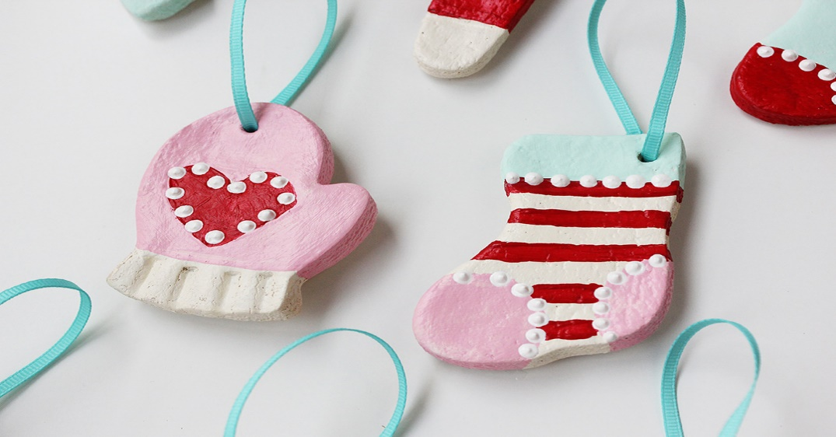

1. **Ice Cube Painting**   
   **Description:** Freeze colored water in ice cube trays and use it to paint.  
   **Materials:** Ice cube tray, food coloring, paper.  
   **Duration:** 30 minutes.

<https://www.youtube.com/watch?v=aXNy96H2whQ>

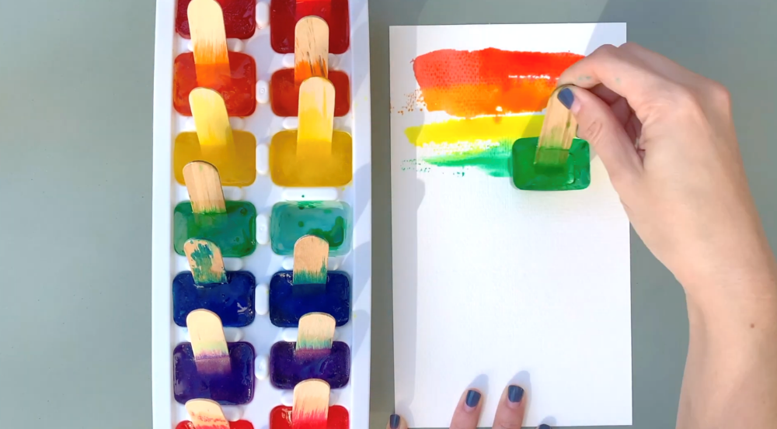

1. **DIY Shakers**

**Description:** Make shakers using bottles and rice or beans, and play rhythms.  
**Materials:** Plastic bottles, rice/beans, tape.  
**Duration:** 20 minutes.

<https://www.youtube.com/watch?v=fZjywurvgEE>  
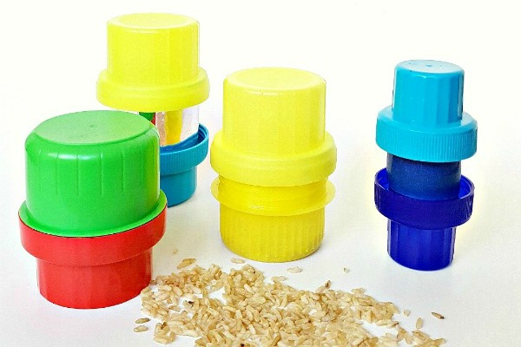

1. **Singing with Puppets**  
   **Description:** Create puppets and use them for sing-along sessions.  
   **Materials:** Socks, buttons, glue.  
   **Duration:** 20-30 minutes.

<https://www.youtube.com/shorts/0uv0apqo8pY>

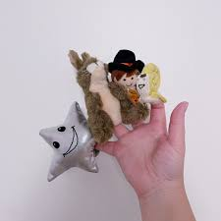

1. **Pot-and-Pan Drumming**

**Description:** Create beats using pots, pans, and spoons.  
**Materials:** Pots, pans, spoons.  
**Duration:** 15-20 minutes.

<https://www.youtube.com/watch?v=bn7xqi-BcQQ>  
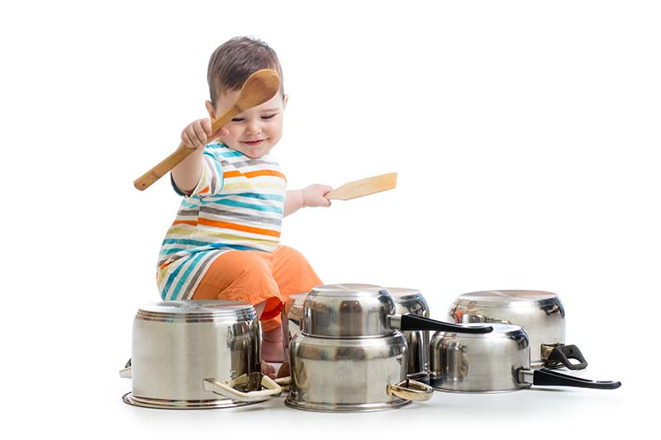

1. **Dress-Up Drama**  
   **Description:** Dress up and act out favorite stories.  
   **Materials:** Old clothes, accessories.  
   **Duration:** 30 minutes.

<https://www.youtube.com/watch?v=0nEJHvO1sns>

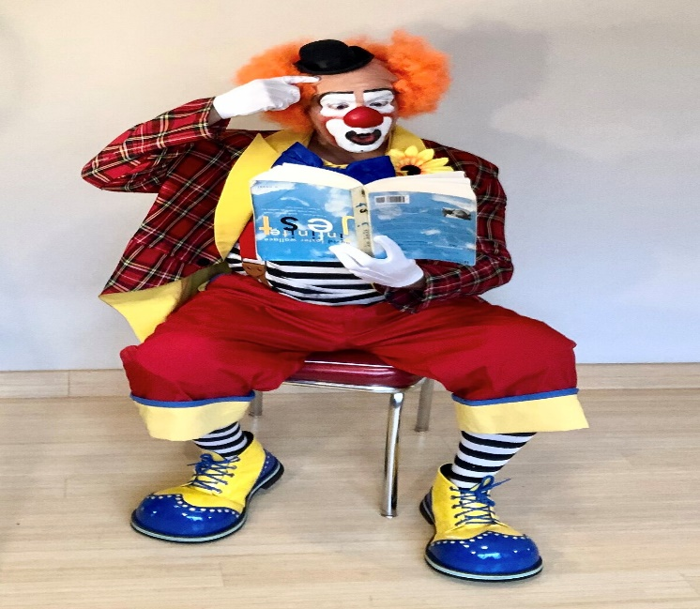

1. **Animal Role Play**  
   **Description:** Pretend to be different animals and act out their habits.  
   **Materials:** None.  
   **Duration:** 20 minutes.

<https://www.youtube.com/watch?v=gu1iaQ8Hw2M>

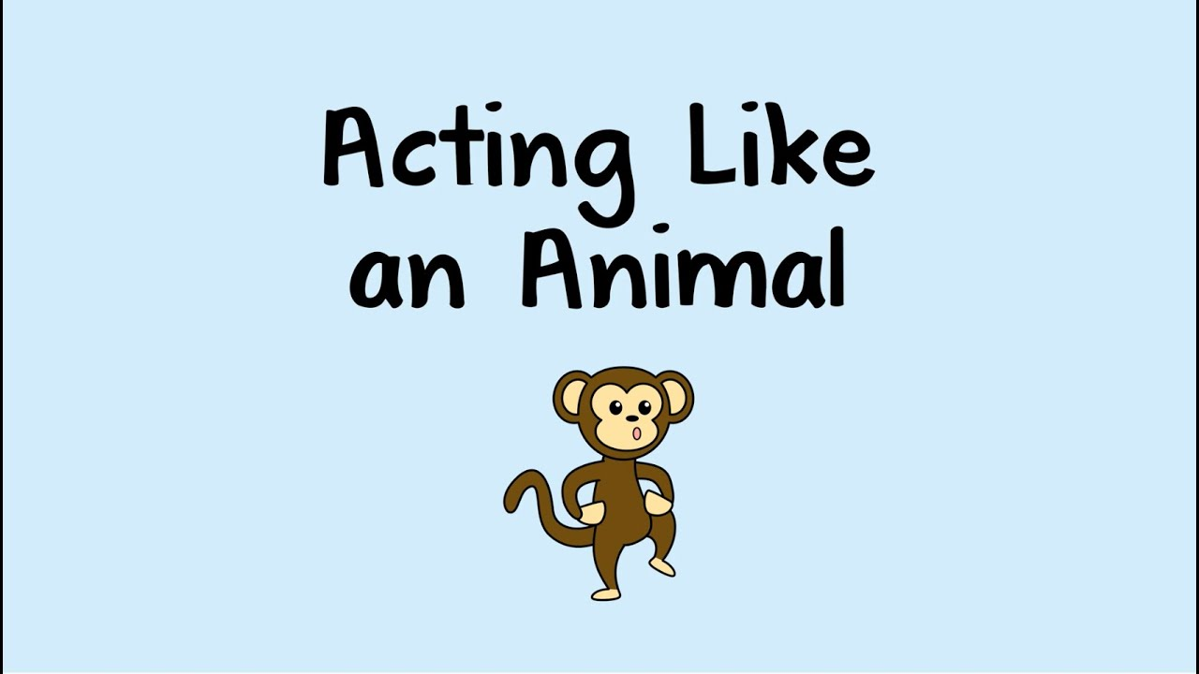

1. **Rainy-Day Rainbows**

**Description:** Use a CD to reflect light and create rainbows on the wall.  
**Materials:** CD, flashlight.  
**Duration:** 20 minutes.

<https://www.youtube.com/watch?v=OQQ9-IBOAmA>  
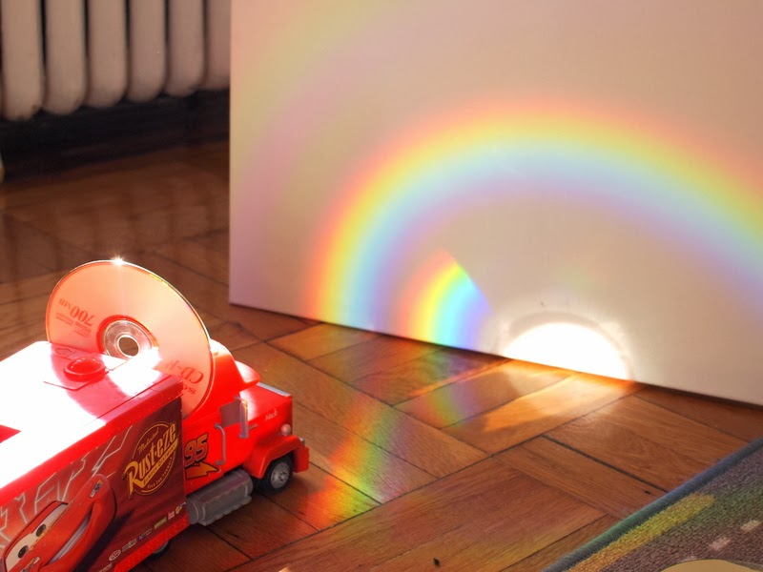

1. **Colour Sorting Game**

**Description:** Gather various small objects and sort them by colour into groups.  
**Materials:** Household items (e.g., buttons, socks, toys), baskets or bowls.  
**Duration:** 15 minutes.

<https://www.youtube.com/shorts/8LanR6VRgwE>

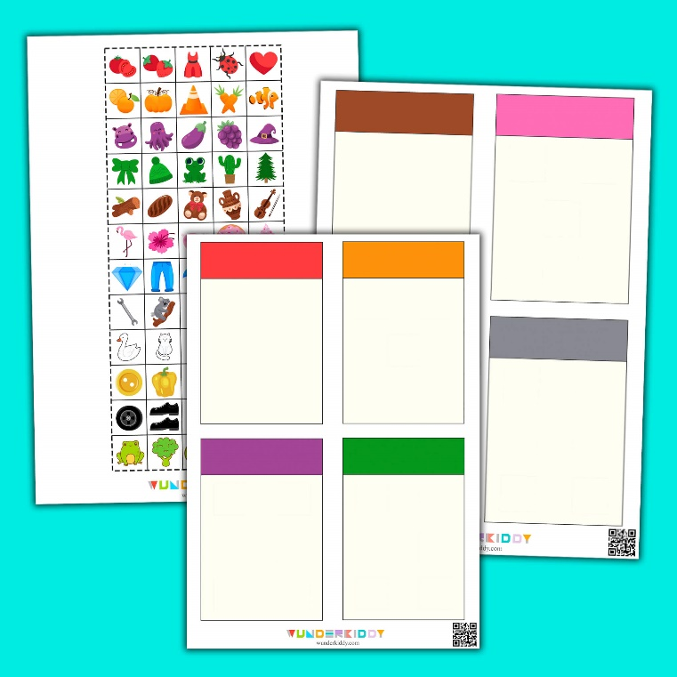

**FOR 6-8 YEARS OLD CHILDREN**

**Arts and Craft Activities**

1. **Origami Creations**

**Description:** Fold paper to create animals, boats, or flowers.  
**Materials:** Paper.  
**Duration:** 30 minutes.

<https://www.youtube.com/shorts/_lE7r7i79vI>  
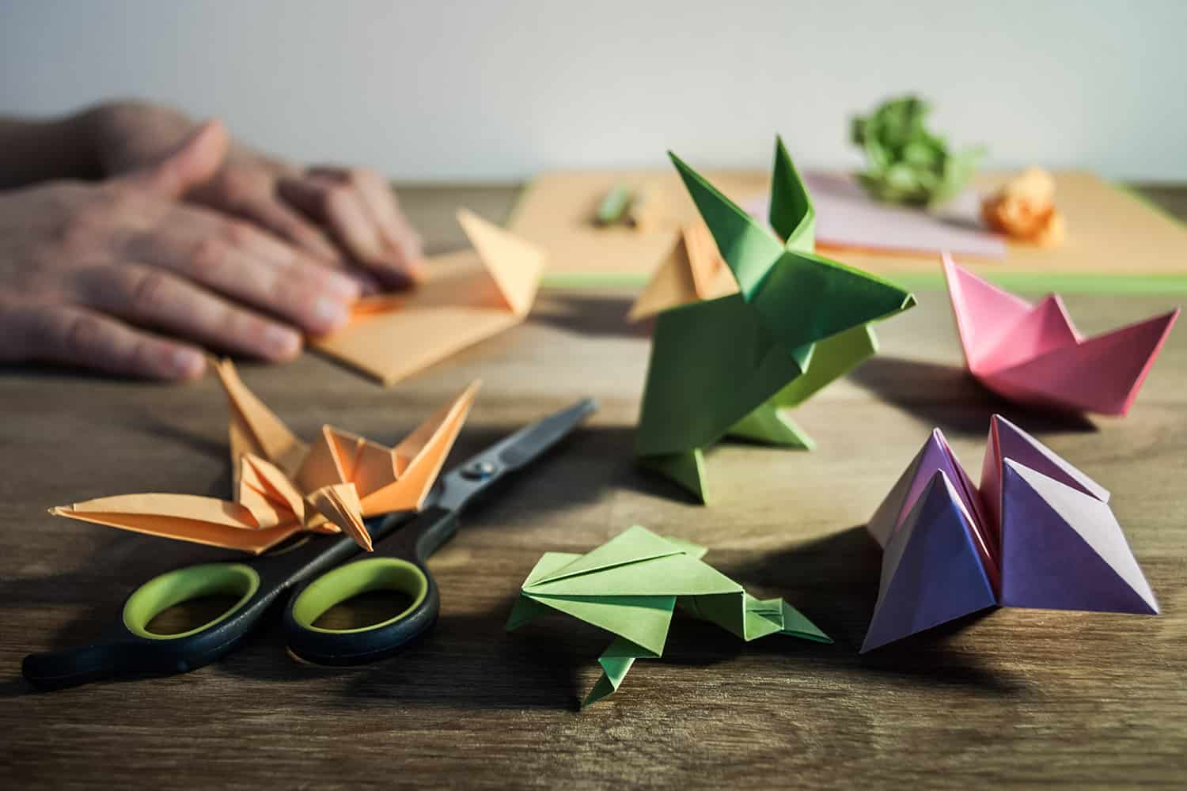

1. **DIY Comic Book**

**Description:** Draw and write a comic story with their own characters.  
**Materials:** Paper, markers, crayons.  
**Duration:** 40-60 minutes.

<https://www.youtube.com/shorts/nuDMuPkQIs0>  
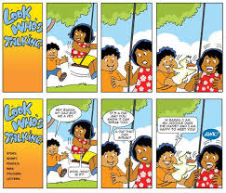

1. **Handprint Family Tree**  
   **Description:** Use handprints to create a family tree.  
   **Materials:** Paper, paint, markers.  
   **Duration:** 30-45 minutes.

<https://www.youtube.com/watch?v=wwUfZioCco0>

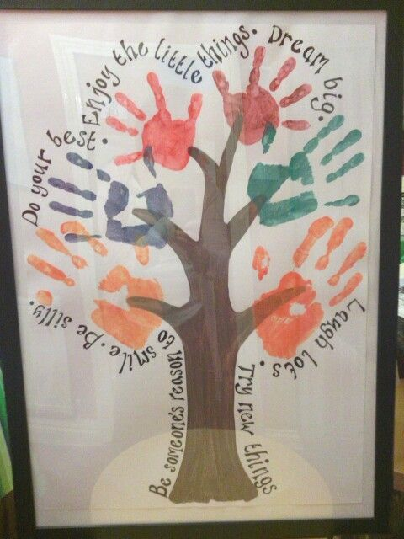

1. **Mosaic Art**   
   **Description:** Cut colorful paper into small pieces and create mosaic designs.  
   **Materials:** Colored paper, glue, scissors.  
   **Duration:** 30 minutes.

<https://www.youtube.com/shorts/p5wRqaKFP1c>

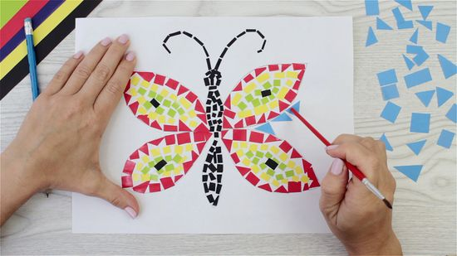

1. **Friendship Bracelets**

**Description:** Make simple bracelets by braiding yarn or string. **Materials:** Yarn, thread, beads (optional). **Duration:** 20-30 minutes.

<https://www.youtube.com/shorts/FJjBbkFhDQM>  
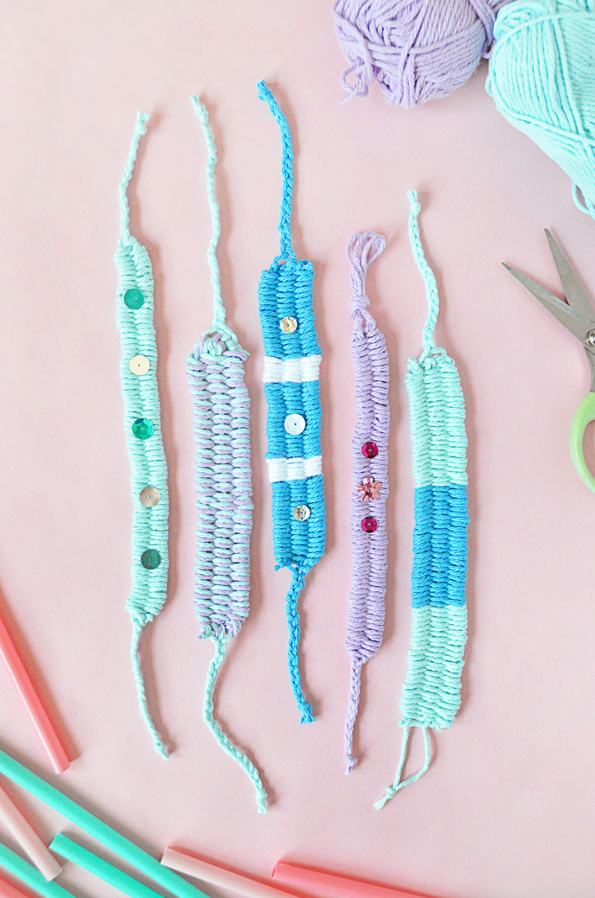

1. **Sink or Float Experiment**

**Description:** Test which items sink or float and make a list of observations.  
**Materials:** Water, bowl, small household items.  
**Duration:** 20 minutes.

<https://www.youtube.com/shorts/Iqgbm872-Nc>

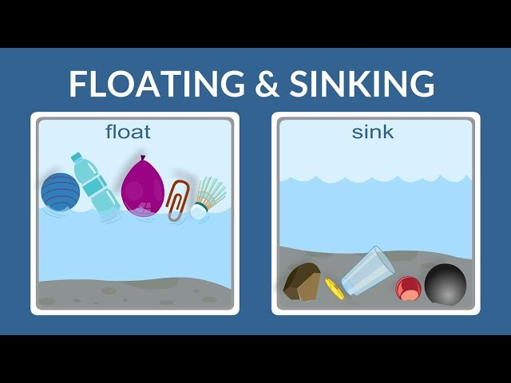

1. **Homemade Slime**  
   **Description:** Mix ingredients to make slime and explore textures.  
   **Materials:** Glue, baking soda, contact solution, food coloring.  
   **Duration:** 30 minutes.

<https://www.youtube.com/shorts/77xT3jTP8oQ>

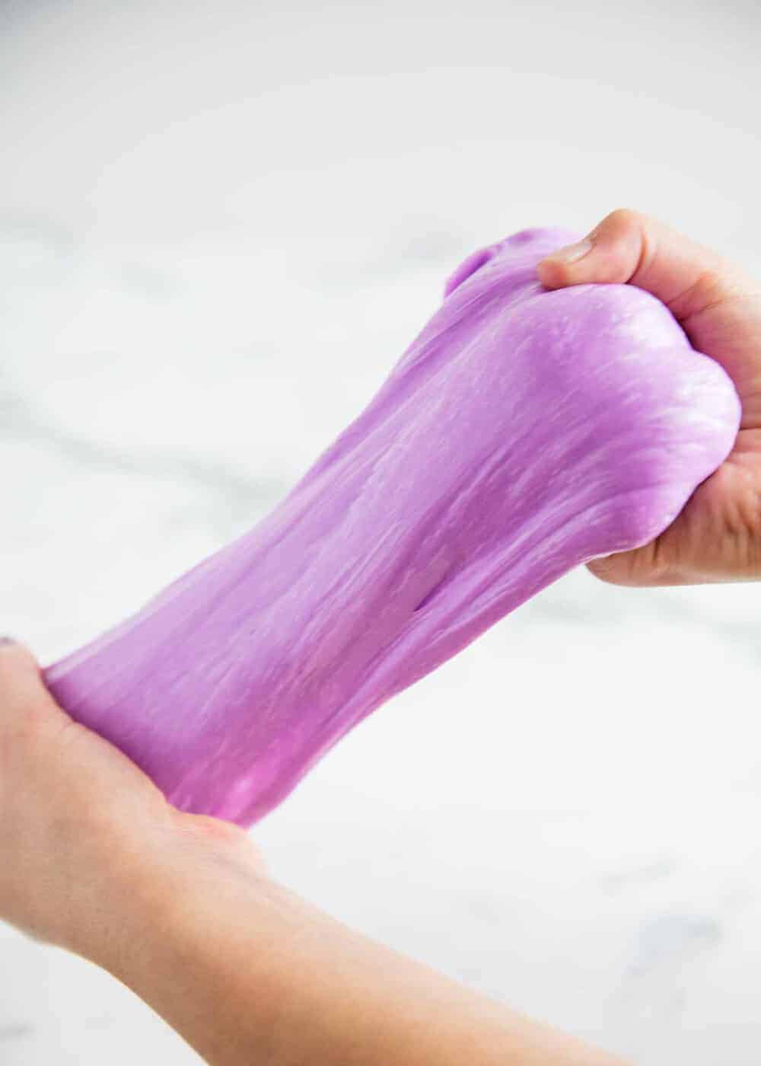

1. **Rock Painting**

**Description:** Collect small rocks and paint them with fun designs.  
**Materials:** Rocks, paint, brushes.  
**Duration:** 30 minutes.

<https://www.youtube.com/shorts/AYGRXO0ev3g>

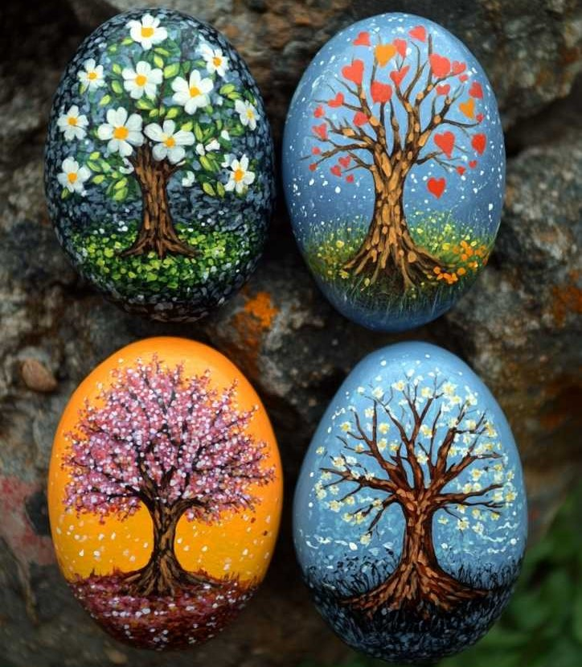

1. **Make a Rainbow Sandwich**

**Description:** Create a colorful sandwich with different fillings.  
**Materials:** Bread, vegetables, spreads.  
**Duration:** 30 minutes.

<https://www.youtube.com/shorts/9anwcoVuJHs>

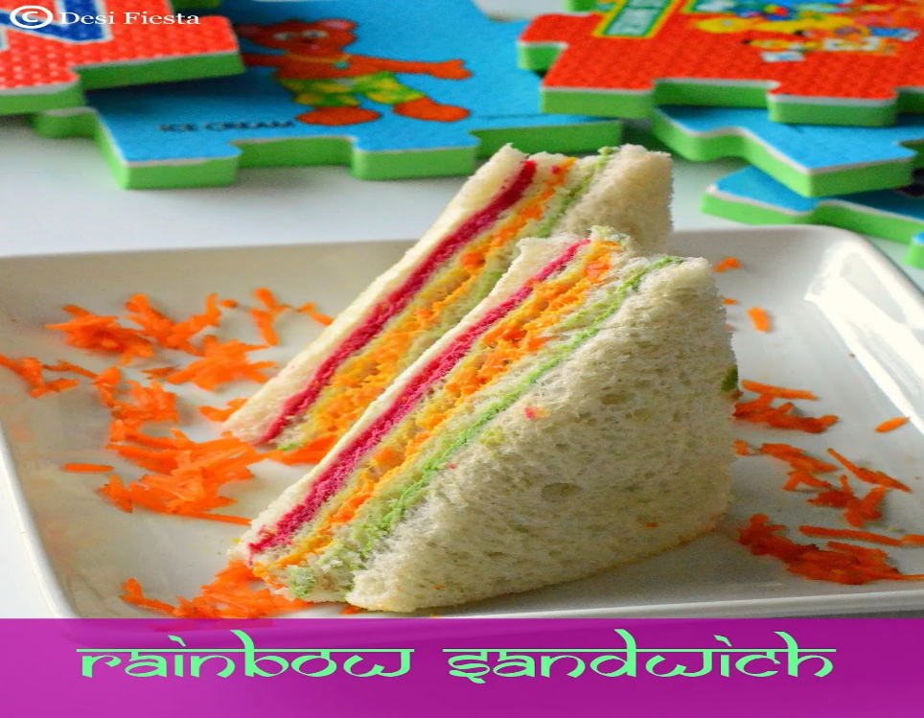

1. **DIY Bookmarks**

**Description:** Decorate simple bookmarks for books.  
**Materials:** Paper, markers, stickers, ribbon.  
**Duration:** 20 minutes.

<https://www.youtube.com/shorts/6bbCLjriHis>

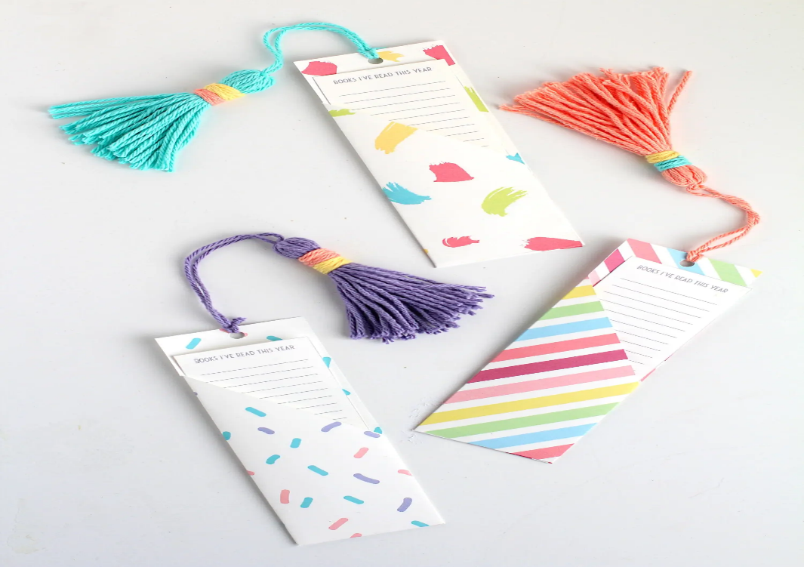

1. **Button Art**

**Description:** Arrange buttons to form pictures or patterns on paper.  
**Materials:** Buttons, glue, paper.  
**Duration:** 15-20 minutes.

<https://www.youtube.com/watch?v=SXrUCWPv4Ys>  
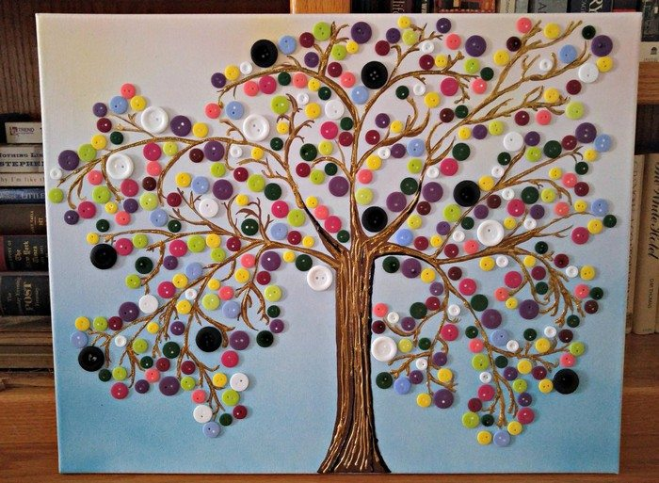

1. **Edible Art**  
   **Description:** Use fruits, vegetables, or bread to create edible art.  
   **Materials:** Various foods, plate, utensils.  
   **Duration:** 30 minutes.

<https://www.youtube.com/watch?v=smTCmhkFcm8>

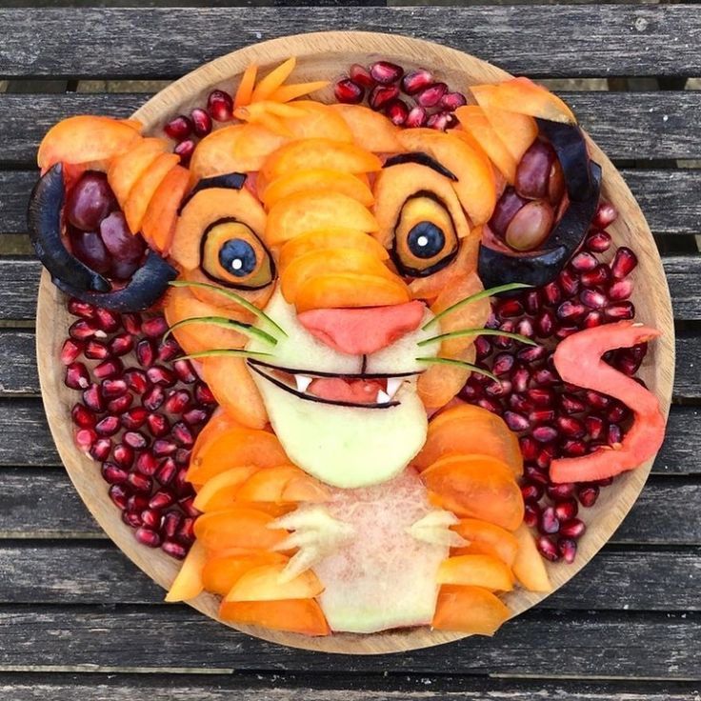

1. **Paper Fans**  
   **Description:** Fold and decorate paper to make colorful fans.  
   **Materials:** Paper, markers, tape or staples.  
   **Duration:** 10 minutes.

<https://www.youtube.com/shorts/5Qlh9WtaM84>

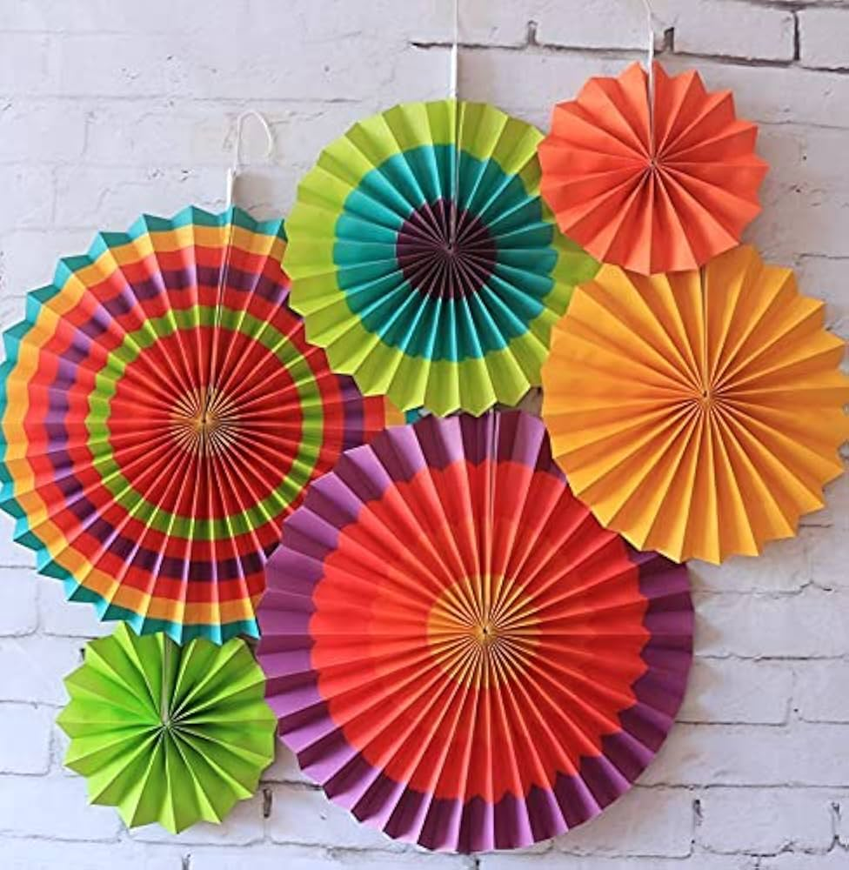

1. **Homemade Drums**

**Description:** Turn containers into drums and play rhythms.  
**Materials:** Empty cans or boxes, spoons, balloons, a pair of scissors.  
**Duration:** 20 minutes.

<https://www.youtube.com/shorts/ZihzUh8UF7M>

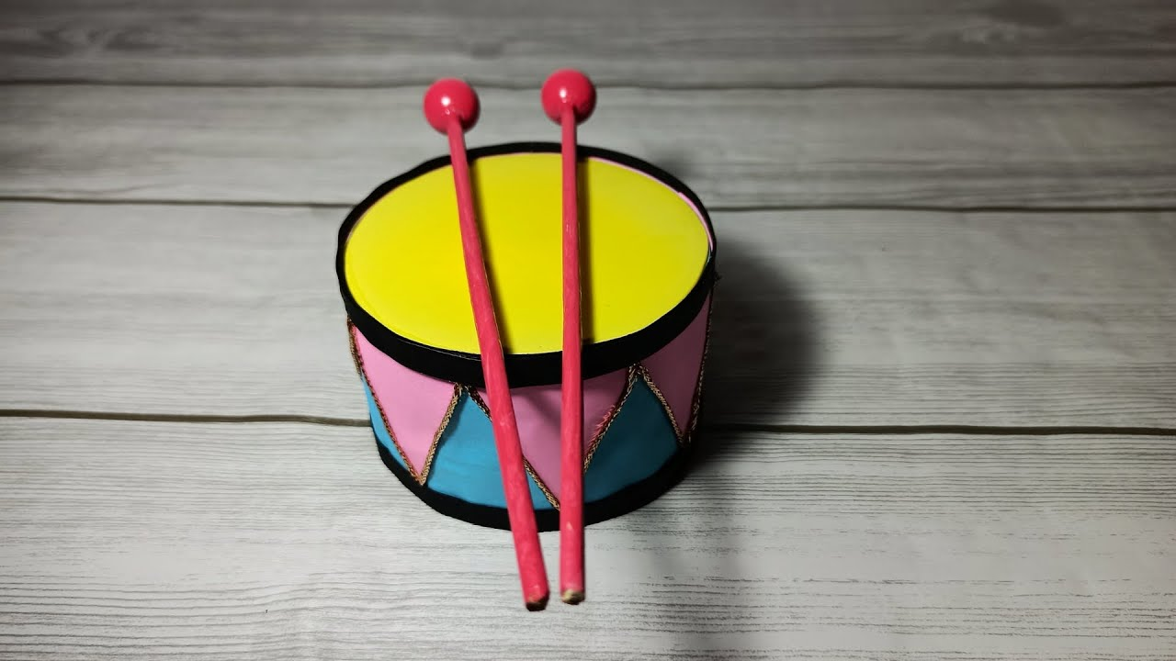

1. **Cardboard Castle**  
   **Description:** Build and decorate a castle out of cardboard.  
   **Materials:** Cardboard, markers, tape.  
   **Duration:** 60 minutes.

<https://www.youtube.com/shorts/HVHokhAwT5s>

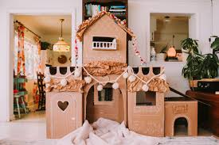

1. **Nature Jar**

**Description:** Collect small natural items like leaves, twigs, or flowers and arrange them in a jar as a mini-display.  
**Materials:** Jar, natural objects.  
**Duration:** 20 minutes.

<https://www.youtube.com/shorts/ekl3mmMePRw>

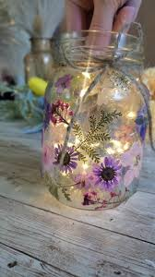

1. **Sensory Mystery Box**

**Description:** Place items in a box, and let kids guess what they are by touch alone.  
**Materials:** Box, various small household objects (spoon, sponge, ball, etc.).  
**Duration:** 15 minutes.

<https://www.youtube.com/watch?v=Xd9b2osSpNA>  
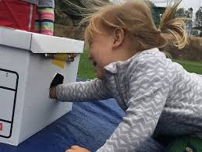

1. **Make a Personal Flag**  
   **Description:** Design and color a flag that represents their personality or interests.  
   **Materials:** Paper, markers, crayons, tape.  
   **Duration:** 20-25 minutes.

<https://www.youtube.com/watch?v=yqmblbvGUSg>

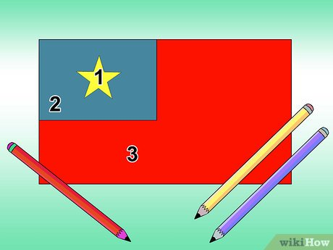

1. **Pillow Fort**  
   **Description:** Build a fort with pillows and blankets, then pretend it's a castle or spaceship.  
   **Materials:** Pillows, blankets.  
   **Duration:** 30 minutes.

<https://www.youtube.com/shorts/yfvx5JAFBmU>

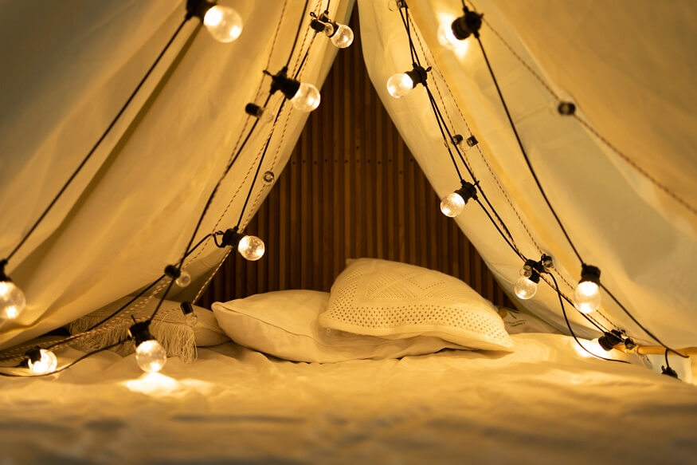

1. **Build a Bridge**

**Description:** Design a bridge using craft sticks that can hold a small object.

**Materials:** Craft sticks, glue.

**Time Duration:** 40 minutes.

[**https://youtu.be/s3HZievz_3Y?si=auncHBf27CjnJpJv**](https://youtu.be/s3HZievz_3Y?si=auncHBf27CjnJpJv)

